**DAILY ONLINE ACTIVITIES SUMMARY**

|  |  |  |  |  |  |  |  |  |
| --- | --- | --- | --- | --- | --- | --- | --- | --- |
| **Date:** | **19/05/2020** | | | | | **Name:** | **Chandana S** | |
| **Sem & Sec** | **4th SEM ‘A’ Section** | | | | | **USN:** | **4AL18CS016** | |
| **Online Test Summary** | | | | | | | | |
| **Subject** | | **Design and Analysis of Algorithms(18CS42)** | | | | | | |
| **Max. Marks** | | **30** | | **Score** | | | **18** | |
| **Certification Course Summary** | | | | | | | | |
| **Course** | **Python for Machine Learning** | | | | | | | |
| **Certificate Provider** | | | **Great Learning** | | **Duration** | | | **2 Hours** |
| **Coding Challenges** | | | | | | | | |
| **Problem Statement:** **A user will input two strings, and we find if one of the strings is a sub sequence of the other. Program prints “yes” if either the first string is a sub sequence of the second string or the second string is a sub sequence of the first string.**  **Assume that, the length of the first string is smaller than or equal to the length of the second string.**  **An expected output of the program:**  **Input the first string**  **tree**  **Input the second string**  **Computer science is awesome**  **YES** | | | | | | | | |
| **Status: Completed** | | | | | | | | |
| **Uploaded the report in Github** | | | | | **Yes** | | | |
| **If yes Repository name** | | | | | **https://github.com/chandushivalingareddy/lockdown-coding** | | | |
| **Uploaded the report in slack** | | | | | **Yes** | | | |

ONLINE TEST DETAILS:

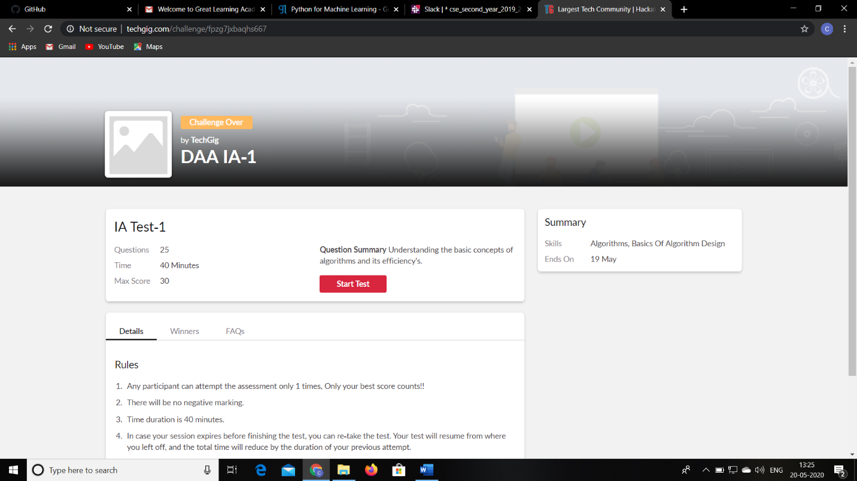

CERTIFICATION COURSE DETAILS:

Python for Machine Learning: The topics covered under Python for Machine Learning are

1.NumPy Introduction-2

2.Saving and Loading NumPy Array-2

3.Pandas -Introduction-2

4.Pandas-Series and Dataframes-2

5.Pandas-Accessing and Modifying-2

6.Pandas-Combining Dataframes-2

7.Pandas-Functions-2

8.Pandas-Saving and Loading Dataframes-2

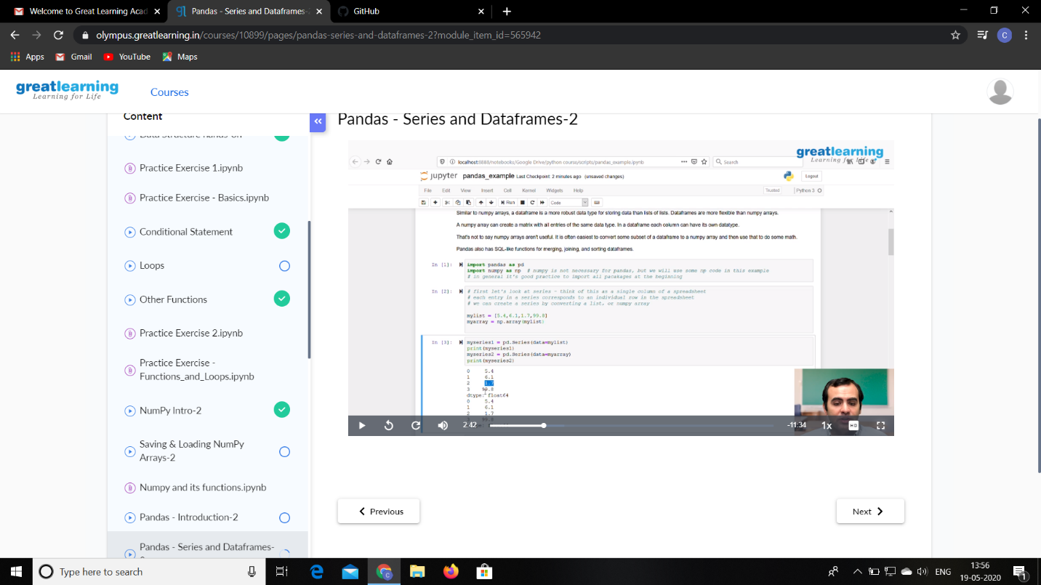

CODING CHALLENGES DETAILS:

A user will input two strings, and we find if one of the strings is a sub sequence of the other. Program prints “yes” if either the first string is a sub sequence of the second string or the second string is a sub sequence of the first string.

Assume that, the length of the first string is smaller than or equal to the length of the second string.

An expected output of the program:

Input the first string

tree

Input the second string

Computer science is awesome

YES

